**Project Design Phase**

**Solution Architecture**

|  |  |
| --- | --- |
| Date | 27 July 2025 |
| Team ID | LTVIP2025TMID36444 |
| Project Name | Transfer learning-based classification of poultry diseases for enhanced health management |
| Maximum Marks | 4 Marks |

**Solution Architecture:**

Solution architecture is a complex process – with many sub-processes – that bridges the gap between business problems and technology solutions. Its goals are to:

* Find the best tech solution to solve existing business problems.
* Describe the structure, characteristics, behavior, and other aspects of the software to project stakeholders.
* Define features, development phases, and solution requirements.
* Provide specifications according to which the solution is defined, managed, and delivered.

**Example - Solution Architecture Diagram:**

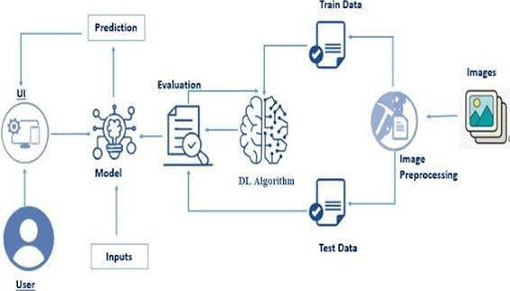

*Figure 1: Proposed System Architecture for Poultry Disease Detection Using AI*

**Reference:** [**https://www.google.com/search?q=poutry+disese+identificqation+architecture&rlz=1C1VDKB_enIN1088IN1088&oq=poutry+disese+identificqation+architecture&gs_lcrp=EgZjaHJvbWUyBggAEEUYOTIJCAEQIRgKGKABMgkIAhAhGAoYoAEyBwgDECEYjwLSAQkxNTUzOGowajeoAgiwAgHxBehzOt9pu4Lw8QXoczrfabuC8A&sourceid=chrome&ie=UTF-8**](https://www.google.com/search?q=poutry+disese+identificqation+architecture&rlz=1C1VDKB_enIN1088IN1088&oq=poutry+disese+identificqation+architecture&gs_lcrp=EgZjaHJvbWUyBggAEEUYOTIJCAEQIRgKGKABMgkIAhAhGAoYoAEyBwgDECEYjwLSAQkxNTUzOGowajeoAgiwAgHxBehzOt9pu4Lw8QXoczrfabuC8A&sourceid=chrome&ie=UTF-8)